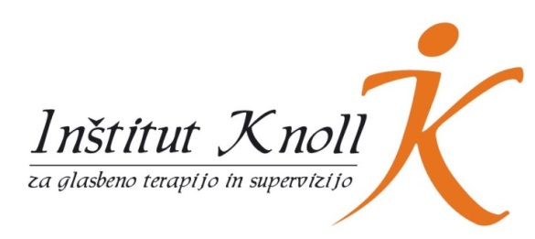
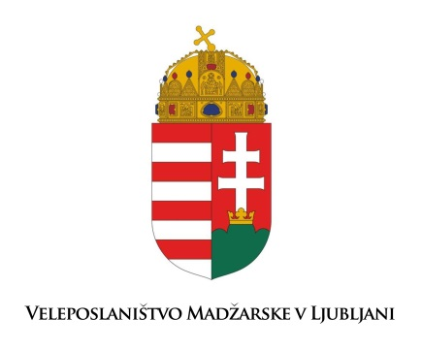
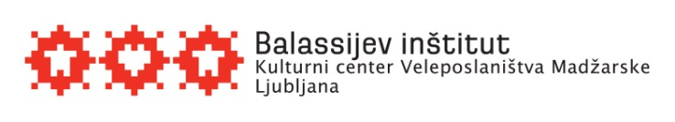

International symposium: Music Therapy with Children with Autism
APPLICATION FORM
Balassi institute, Barvarska steza 8, Ljubljana, sobota, 16. Februar 2019

NAME ___________________________________________________________________
EMAIL ______ _____________________________________________________________
COUNTRY, POST ADRESS ___________________________________________________________
PROFESSION _____________________________________________________________________
I ATTEND THE SYMPOSIUM (please mark):
☐ as parent/relative of a child with autism
☐ as professional, working with children with autism at ________________________________
(please name the kind of institution, you are working in )
☐ as student of music therapy
☐ as music therapist
☐ because I am interested in music therapy
PAYMENT (please mark)
☐ I pay the fee by myself.
☐ The registration fee will be payed by my institution.
Details of the institution as should be written on the invoice:
___________________________________________________________________________

WORKSHOP CHOICE
A) dr. Tali Gottfried: »Music as a tool to support interactions with children with autism« – a workshop open for parents and professionals
B) Laura Blauth: »Let’s do music together!« – musical activities to facilitate social interactions and positive group experiences – open to all participants
C) dr. Petra Kovacs: »Connecting through music« – an interactive workshop for professionals and family members

Please fill in your first and second workshop choice. (In case that your first choice is full, you will be included in the second workshop of your choice.)
1. choice: ________
2. choice: ________
REGISTRATION FEE
Early bird application: until 21. december 2018: 60€ (40€ for students and unemployed persons)
Regular application: after 22. december 2018 until 31. january 2019: 80€ (60€ students/unemployed)
Please transfer your registration fee to the following bank account:
Account holder:
Inštitut Knoll za glasbeno terapijo in supervizijo, Savska cesta 22A, 4000 Kranj, Slovenia
IBAN: SI56 6000 0000 0444 331, Bank: Hranilnica LON d.d. Kranj, Slovenia
BIC/SWIFT: HLONSI22
Purpose: »name, surename«, International Symposium Ljubljana
AGREEMENT
☐ I do agree, that Institute Knoll uses my contact details exclusively for the purpose of the symposium I am applying to.
☐ I do also agree, that my contact details may be used for the purpose of inviting me to other such events, organised by the Institute Knoll in the future. My details will not be published or handed over to a third party.
Please send your application form and a copy of your payment confirmation to: institutknoll@yahoo.com
For all further information please dont hesitate to contact us via email.

